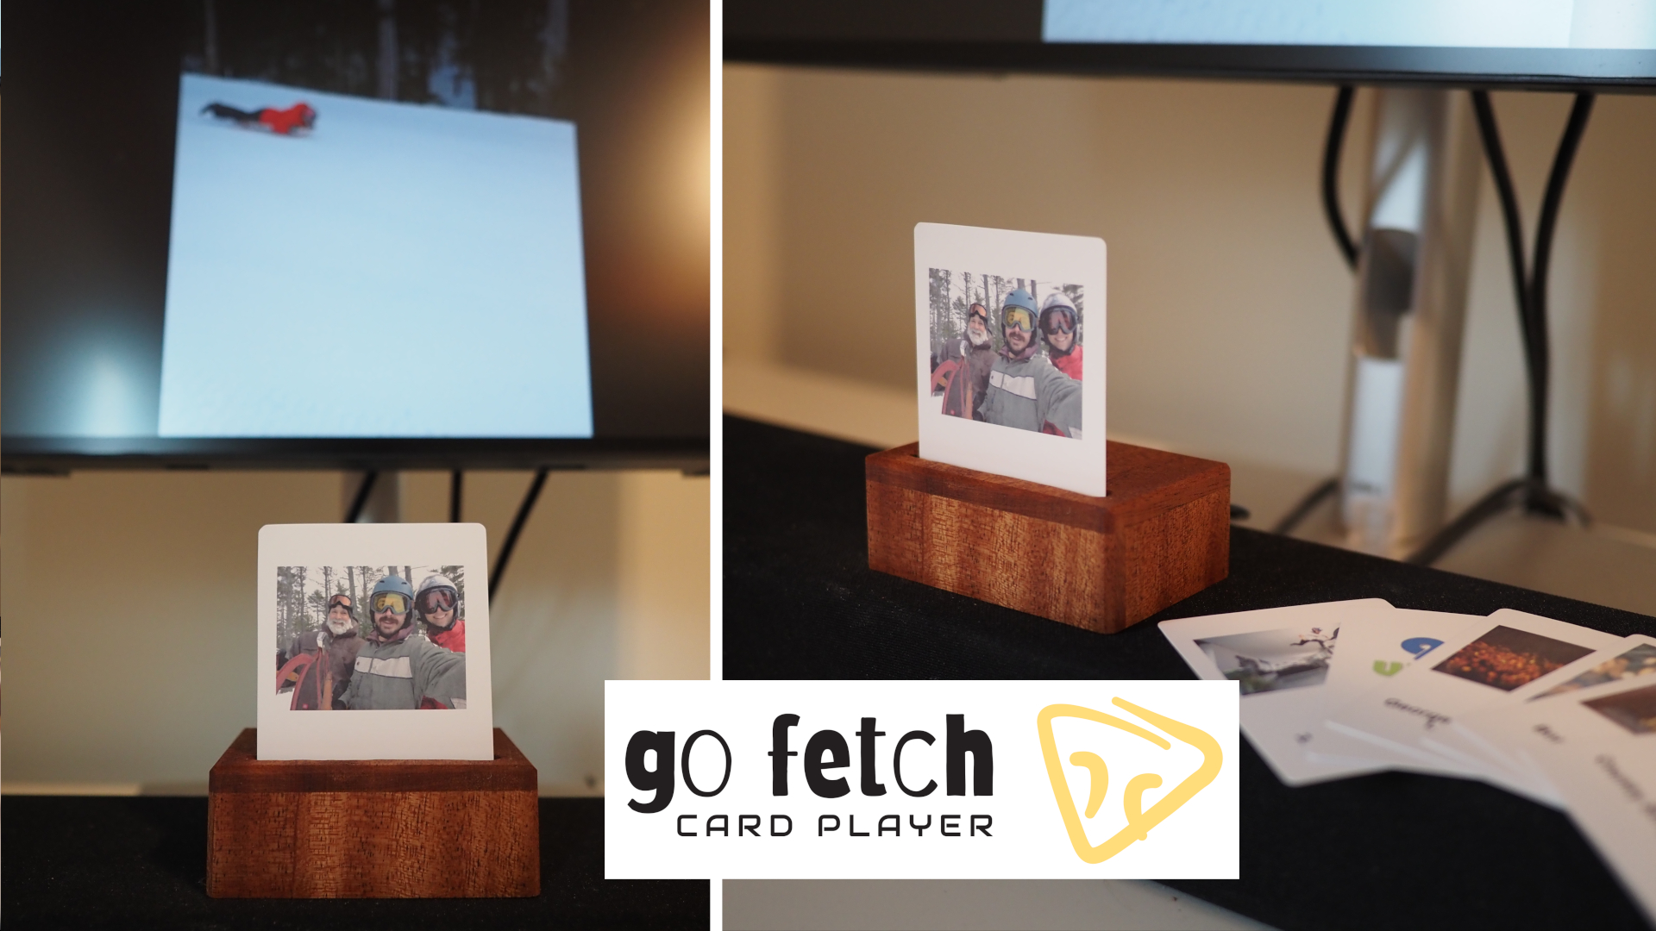
Hardware Guide:

- Inner Enclosure: The hardware is designed around a laser cut inner enclosure that holds all electronics and the inserted card. The inner enclosure is 1/8” or 3mm thick.
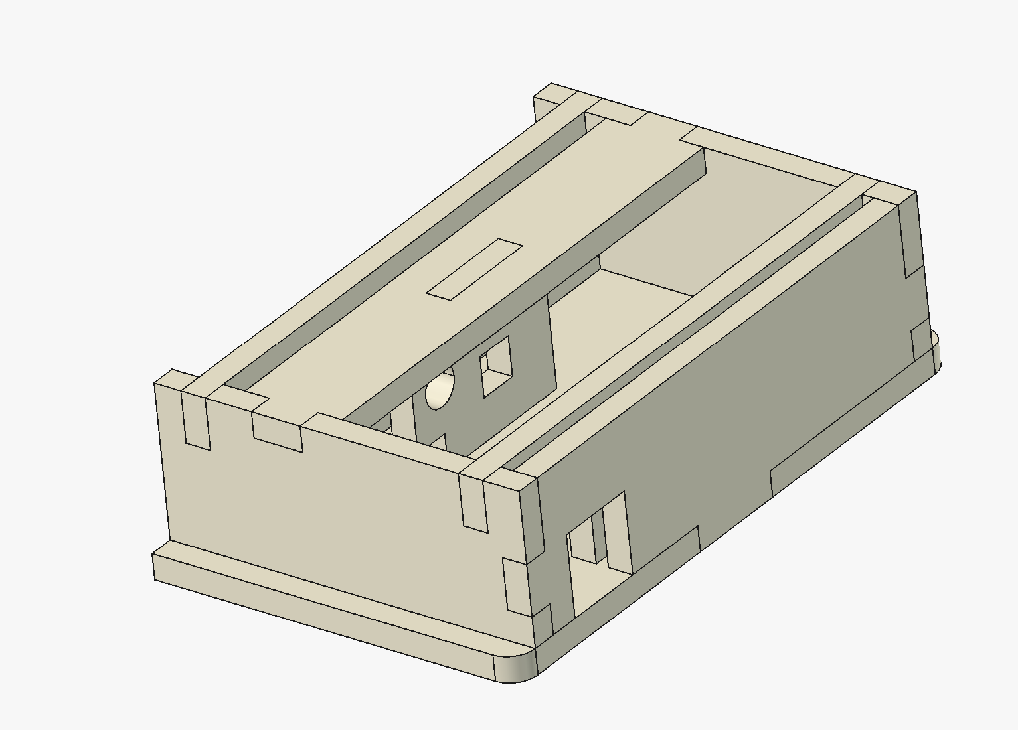

- Outer Enclosure: 4 sided outer enclosure (¼” thick), inner enclosure slides into it from the back friction fit.

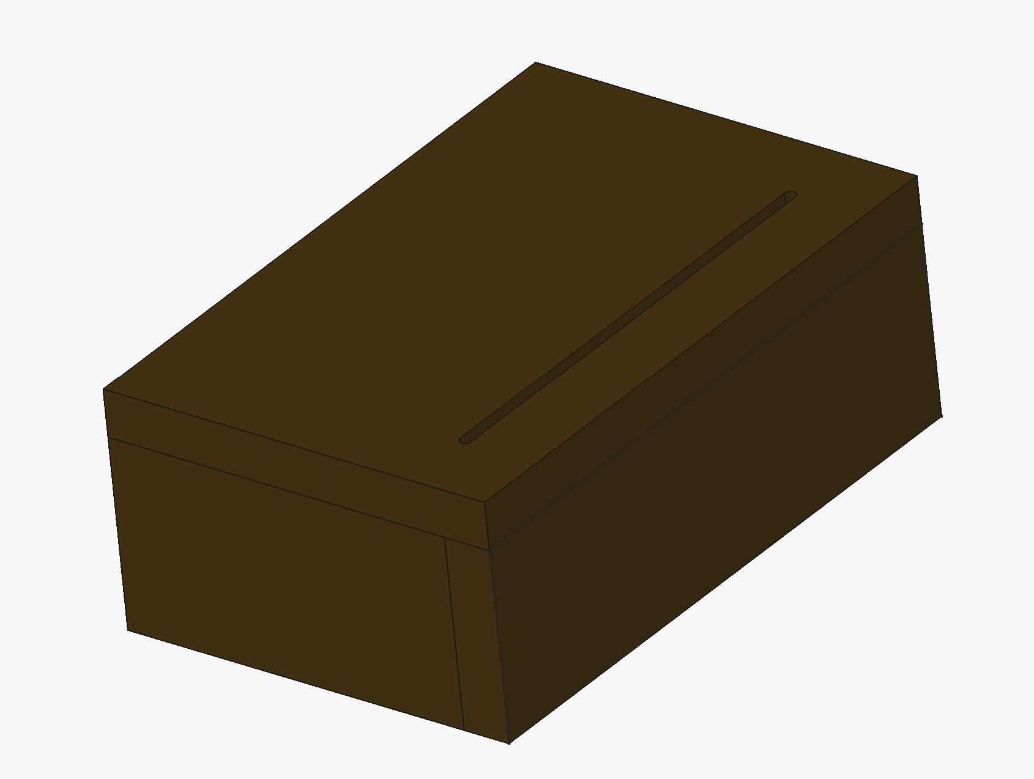

- Electronics: Note will need STEMMA/Qwiic connector cable for tiny code reader. Top optional direct solder part of the board needs to be clipped off for it to fit in the enclosure. Images helpful for assembly in images folder
